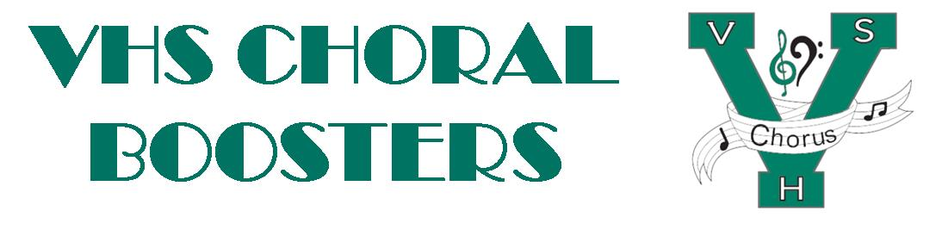
VHSChorus.org
VHSChoralboosters@gmail.com
www.facebook.com/vhschorus

Booster Meeting
Thursday, April 7, 2022
Agenda
Welcome and Introduction of Board Members
Financial Report/Budget
MPA Follow-up
Singers Showcase – April 8
Sponsorship
Dessert Auction
Ticket sales and publicity
Programs
Disney trip
Meetings: May 24th at 7pm
Payment due dates: Apr. 18th
Fundraising update
Awards Ceremony
New format
Volunteers
Summer camp
Leadership: July 22nd - 23rd
Choir Camp: July 30th -31st
Election of Officers
President
Vice President
Secretary
Treasurer
Treasurer elect? Media chair?
Upcoming dates:
May 12th – Spring Concert, 7pm
May 18th – Chorus Awards, 7pm

