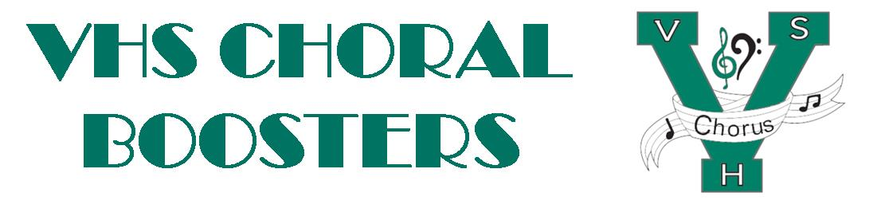
VHSChorus.org
VHSChoralboosters@gmail.com
www.facebook.com/vhschorus

Booster Meeting
Thursday, April 6, 2023
Agenda

Welcome and Introduction of Board Members

Financial Report/Budget

Officer updates

Singer’s Showcase follow up

New York Trip updates

Election of officers

Upcoming dates:
Tuesday, May 9th 7pm Chorus Spring Concert
Tuesday, May 16 – Chorus Awards Night – families invited to attend

Future meeting dates:

