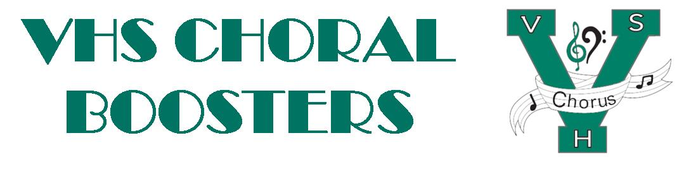
VHSChorus.org
VHSChoralboosters@gmail.com
www.facebook.com/vhschorus

Booster Meeting
Thursday, February 3, 2022
Agenda
Welcome and Introduction of Board Members
Financial Report/Budget
MPA –March 2-4. 2022
Concessions team needed!
Watch for Sign up genius to volunteer
Singers Showcase – April 8
Sponsorship
Dessert Auction
Ticket sales and publicity
Disney trip
Meetings: February 17th and May 24th at 7pm
Payment due dates: Nov. 15th, Jan. 18th, Mar. 1st, and Apr. 18th
Students may still join, until the bus is full!
Department/Tri-M Project ideas
Bulletin Board
Pillar wraps
MPA Celebration – March 25th at 6pm
Madrigal follow up
How do you think it went?
What should we do differently?
What information do you wish you would have had?
What’s next?
Upcoming dates:
May 12th – Spring Concert, 7pm
May 18th – Chorus Awards, 7pm
Future meeting dates:
April 7

