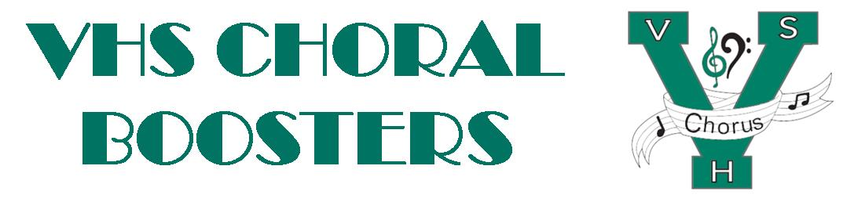
VHSChorus.org
VHSChoralboosters@gmail.com
www.facebook.com/vhschorus

Booster Meeting
Tuesday, November 3, 2022
Agenda

Welcome and Introduction of Board Members

Financial Report/Budget

Treasurer position

Officer updates

Holiday Parade – Nov. 26

Travel

Madrigal
Tickets
Sign Up Genius
Dress rehearsal, Dec 2, Performances, Dec 3 & 4
Madrigal subcommittees
Costumes – Angela Lawson
Food – Jan Lane
Tickets and Publicity – Pandora Wood
Construction/decor – Wayne Starr
Tables – Crystal Avella
Chaperones – Donna Kotkiewicz
Madrigal Marketplace – Lisa Singeisen
Donations for Marketplace
Photography and videography

Remind info - @chorusvhs for choir
- @LeVociVHS for Le Voci

Future meeting dates: Feb 2, April 6

