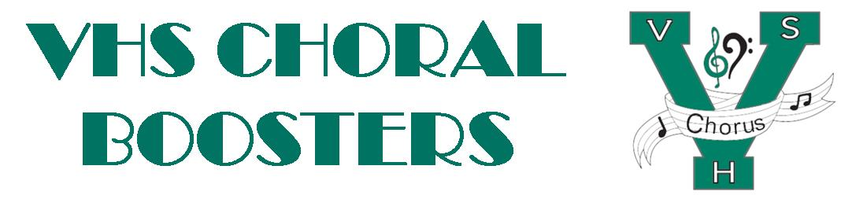
VHSChorus.org
VHSChoralboosters@gmail.com
www.facebook.com/vhschorus

Booster Meeting
Thursday, Sept. 09, 2021
Agenda

Welcome and Introduction of Board Members

Financial Report/Budget

Open board position – Secretary

T-Shirts

Bigs/Littles

Current grades/Assessments

Calendar/Help needed
- All-State
- Madrigal, December 2nd, 3rd, and 4th
  - Costumes, Food, Tickets and Publicity, Construction/décor, Tables (Crystal Coluzzi), Chaperones, Madrigal Marketplace (Lisa Singeisen)
- MPAs, March 2nd, 3rd, and 4th
  - Concessions
- Showcase, Date TBA
  - Business sponsorships
  - Tickets and publicity
  - Dessert auction
Travel

Future meeting dates: Oct 7, Nov 4, Feb 3, April 7

