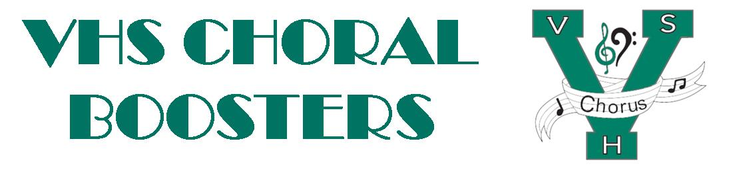
VHSChorus.org
VHSChoralboosters@gmail.com
www.facebook.com/vhschorus

Booster Meeting
Thursday, Sept. 08, 2022
Agenda

Welcome and Introduction of Board Members

Financial Report/Budget

Calendar

Solo and Ensemble

All-state updates

Madrigal

T-shirts – Order now for $10

Bigs and Littles

Officer updates

Grading procedures

Volunteer Eligibility

Remind info 81010 - @chorusvhs for choir
- @LeVociVHS for Le Voci

Future meeting dates: Oct 6, Nov 3, Feb 2, April 6

