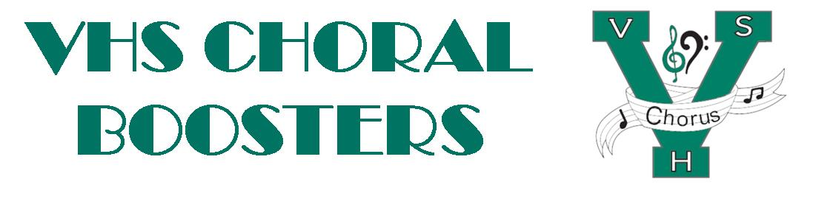
VHSChorus.org
VHSChoralboosters@gmail.com
www.facebook.com/vhschorus

Dear VHS Chorus Supporter,

Our 5th Annual Singer’s Showcase will take place on January 27, 2024. The Singer’s Showcase is a concert event featuring the amazing voices of the Venice High School Choral Program. This year the money raised from this event will go to help students in the VHS Choral program travel to Italy in June, 2024. They will be performing and singing Mass at St. Peter’s Basilica. This is a once in a lifetime opportunity for these students. We are aiming to raise $2000 per student to help defray the cost of the trip.

One of the fundraising elements of our Singer’s Showcase will be an Elegant Dessert Auction. We are seeking donations of desserts that can be used for the auction. We hope that you will consider donating an item. Arrangements can be made for pickup of the item by one of our volunteers the week of January 22nd. Please contact the Choral Boosters at vhschoralboosters@gmail.com to arrange pickup.

We hope that we can count on you to make this year’s event a huge success. Thank you in advance for your support of the Singer’s Showcase and the Venice High School Chorus.

Sincerely,

VHS Choral Boosters
Singer’s Showcase Committee

Name of business: _______________________________________
Contact name: __________________________________________
Contact phone/email: ____________________________________
Item to be donated: ______________________________________

