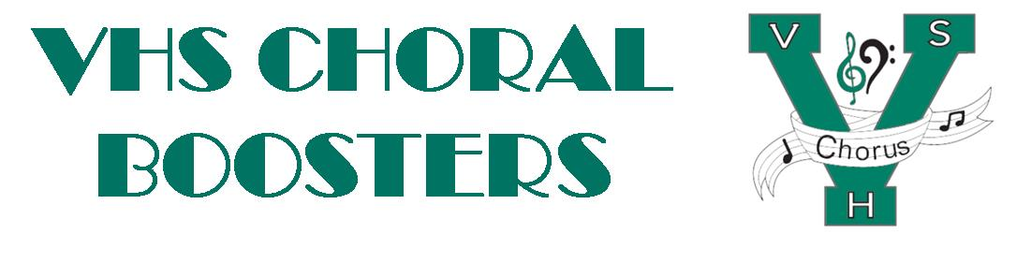
VHSChorus.org
VHSChoralboosters@gmail.com
www.facebook.com/vhschorus
Booster Meeting Minutes
Thursday, February 2, 2023
Start Time 7:03pm
End Time 7:32pm

Welcome and Introduction of Board Members

Financial Report/Budget
-Current Balance is $32,672.00

Officer updates
-Students are working on getting desserts and business sponsors for Showcase
-Concert attire has been reordered
-Choir students are being interviewed on how they feel the Big/Little program is going this year
-Recruitment party on 2/2/23 was a success

Travel updates
-Broadway tickets ordered
-Monday the online fundraiser will go live. It will allow people to shop and donate
-3 Publix Fundraisers will be announced

MPA
Volunteers –
Chaperones
Meal coordination
Concessions

Singer’s Showcase –
-We will be serving appetizers and soft drinks
-Students will need to audition
-Business sponsors will get advertisement

March 25, 4:00 and 7:00
Unity of Venice Church, 125 N. Jackson Road
Volunteers – set up, kitchen, clean up
Tickets-Travelers get $10 of every ticket sold. Please note their name when
ordering on website
Dessert Auction

Award’s Night planning committee
Tuesday, May 16
-We need volunteers to make this night a success!

Remind info - @chorusvhs for choir
- @LeVociVHS for Le Voci

Future meeting dates: April 6 (board elections)

Board meeting was held after Booster meeting.
Board meeting started at 7:37pm
Lisa Singeisen made a motion to use 50% of Castle Madrigal funds for student travel
Jan Lane seconded the motion and all was in favor for 50% of Castle Madrigal funds to go towards student travel
Board meeting ended at 7:39pm

