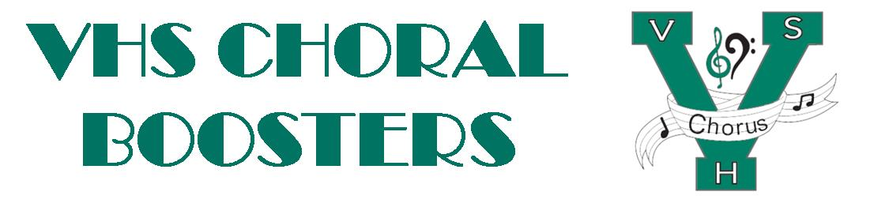
VHSChorus.org
VHSChoralboosters@gmail.com
www.facebook.com/vhschorus

Dear VHS Chorus Supporter,

Our 5th Annual Singer’s Showcase will take place on Saturday, January 27, 2024. This year we are excited to offer two performances at 4:00 p.m. and 7:00 p.m. The Singer’s Showcase is a concert event featuring the amazing voices of the Venice High School Choral Program. This year the money raised from this event will go to help students in the VHS Choral program travel to Italy in June, 2024. They will be performing and singing Mass at St. Peter’s Basilica. This is a once in a lifetime opportunity for these students. We are aiming to raise $2000 per student to help defray the cost of the trip.

We can’t meet our goal without the help of businesses like yours.

As a valuable member of our community we would like to invite your company to be part of the Singer’s Showcase. Would you consider making a donation to be a table sponsor for this event? Sponsorship opportunities are outlined below:

GOLD sponsor- $1000 – includes 8 tickets to your choice of performances, premium
seating, full page, color ad in event program, signage, and recognition at the event
SILVER sponsor- $500 – includes 4 tickets to your choice of performances, premium
seating, half page ad in the event program, recognition at the event
BRONZE Sponsor- $250 – includes 2 tickets to your choice of performances, premium
seating, small ad in the event program, recognition at the event

This year’s Singer’s Showcase will be held at Unity of Venice, 125 N. Jackson Road in Venice. The event will feature appetizers and beverages followed by a phenomenal concert featuring members of the VHS Choral program. There will also be an elegant dessert auction.

We hope that we can count on you to make this year’s event a huge success. Thank you in advance for your sponsorship. We hope to see you at the Singer’s Showcase.

Sincerely,

VHS Choral Boosters
Singer’s Showcase Committee

